Hướng dẫn chạy

1. Để folder 20205128 vào htdocs của xampp

2. Thay đổi script.js: Cần thay đổi **clientID**, **clientSecret:**

- Vào link dưới để xem hướng dẫn lấy clientID và clientSecret

<https://blogs.classfunc.com/posts/huong-dan-lay-client-id-va-client-secret-tu-google/h3Id1xdsgFw22iJbLmqa?fbclid=IwAR1rgzuA_-3kBqLqGwzol5B9IbzGwPcwwRukuprO0JTNRiWSDRWjp3Vc0mU>

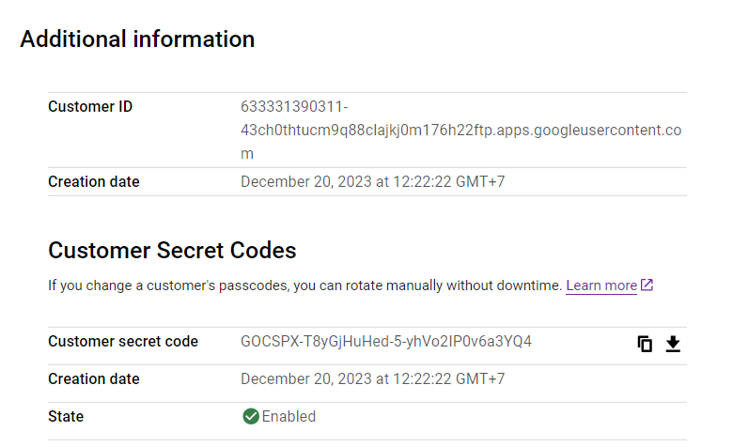

* Gán URL: http://localhost/20205128/page.php vào google cloud console

* Cấp quyền truy cập cho gmail: Vào OAuth consent screen -> Add users -> nhập mail của bạn

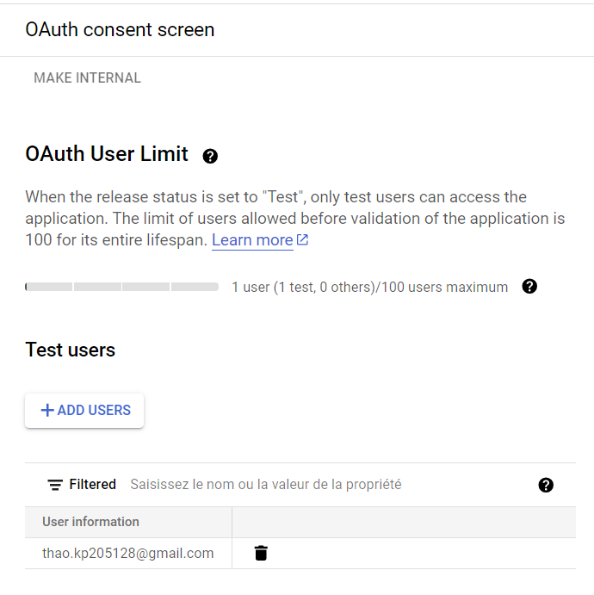

3. Chạy xampp, mở folder 20205128 trong htdocs, chạy file index.php (có thể down Open PHP/HTML/JS in browser trên visual code và nhấp chuột phải chọn Open PHP)

